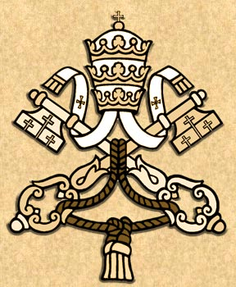

MESSAGE FOR THE
YEAR OF FAITH CLOSING CEREMONY
NOVEMBER 23, 2013

“THE MOST REVEREND JOHN HUNG SHAN-CHUAN
ARCHBISHOP OF TAIPEI
PRESIDENT OF THE CHINESE REGIONAL BISHOPS’ CONFERENCE

THE HOLY FATHER WAS PLEASED TO BE INFORMED OF THE CEREMONY TO MARK THE CLOSING OF THE YEAR OF FAITH, DUE TO TAKE PLACE ON 23 NOVEMBER 2013. HE SENDS CORDIAL GREETINGS TO YOU AND ALL THE BISHOPS, PRIESTS, RELIGIOUS AND LAY FAITHFUL IN TAIWAN AS YOU LIFT UP TO GOD, THROUGH THE EUCHARISTIC SACRIFICE, A FITTING HOMAGE OF PRAISE AND THANKSGIVING FOR THE MANY GRACES AND BENEFITS RECEIVED IN THE PAST YEAR. HIS HOLINESS, IN PARTICULAR, WISHES TO ENCOURAGE YOU IN YOUR EFFORTS TO CONTINUE BUILDING UPON SUCH GRACES BY DEEPENING THE COMMUNION AND MISSION OF THE CHURCH IN TAIWAN THROUGH ASSIDUOUS PRAYERS, ARDENT FAITH AND HOLINESS OF LIFE. IN THIS WAY, SEEING THE BEAUTY OF GOD’S LOVE AT WORK IN THE CHURCH, OTHERS MAY BE DRAWN TO “SHARE AS BROTHERS AND SISTERS IN THAT ONE BLESSING, WHICH ATTAINS ITS FULLNESS IN JESUS” (LUMEN FIDEI, No. 54). WITH THESE THOUGHTS, AND COMMENDING THE CELEBRATIONS OF THE CHURCH IN TAIWAN TO THE LOVING INTERCESSION OF THE BLESSED VIRGIN MARY, HIS HOLINESS GLADLY IMPARTS TO ALL PRESENT HIS APOSTOLIC BLESSING AS A PLEDGE OF JOY AND PEACE IN THE LORD.

CARDINAL TARCISIO BERTONE
SECRETARY OF STATE.”

