Highlights on the
150th Anniversary of Evangelization in Taiwan

Blessings, thanksgiving and honor to God! These were the sentiments that filled the faithful on this lovely island as the Catholic Church in Taiwan ended its 150th anniversary of evangelization. It is then good to look back and recall the many graces we have received throughout this year.

Special Papal Envoy

First of all is the Holy Father Pope Benedict XVI’s special blessing through his envoy, His Eminence Jozef Cardinal Tomko. We know that Cardinal Tomko is Prefect Emeritus of the Congregation for the Evangelization of Peoples and President Emeritus of the Pontifical Committee for the International Eucharistic Congresses. Thus, his participation brought to light the pope’s presence and gave a universal dimension to our celebration.

Cardinal Tomko arrived from Rome on November 18th, accompanied by Rev. Fr. Antonio Sergianni, PIME. The following day, together with Msgr. Paul Russell, the Papal Representative in Taiwan, they visited Hualien, a diocese badly hit by the August 8th Typhoon Morakot. In Hualien, Cardinal Tomko celebrated Mass and met with the local clergy. In the afternoon of November 20th, Cardinal Tomko had an audience with the President of the Republic of China, Mr. Ma Ying-jeou.

Closing Celebration

As early as Friday (Nov. 20th), busses from all over the island started to arrive in Taipei. Indeed, many participants spent the night in the busses just to be on time for the closing ceremony at the National Taiwan Sport Stadium in Linkou. The closing celebration, “A Ceremony of Witnessing and Thanksgiving,” was finally held on the Solemnity of Christ the King, November 21st (Saturday). This commemoration included a program from 1:00-3:00 pm, followed by a solemn Mass that ended at 5:30 pm.

A symbolic image of a 19th century sailing boat mooring its anchor on the shores of “Formosa Island” was projected on a huge screen in the middle of the stage. Then, the Most Rev. John Hung, SVD, President of the Chinese Regional Bishops Conference, welcomed the faithful in Taiwan, as well as the audience throughout the world to witness together the history of evangelization in Taiwan. Msgr. Hung said that “it is an occasion to give thanks and to remind us of our mission to spread the love of God.”

Awards and testimonies

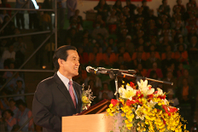 Among the distinguished guests was the President of Taiwan, Mr. Ma Ying-jeou. President Ma expressed his deep gratitude for the great contribution of the Catholic Church to Taiwan, embodied in the missionaries who brought peace, blessings and development to the country. He quoted from the Bible encouraging each one to be the “salt of the earth and the light of the world” (Mt5:13-14).

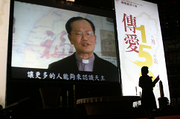 Then, the beginnings and developments of the Catholic Church in Taiwan were presented by the bishops of the dioceses from the South to the North. Catholics from all the dioceses gave brief testimonies on the first missionaries, local priests and religious Sisters, catechists and lay people. A short pass-in-review of the first religious congregations, orphanages, hospitals, universities, seminary, pastoral centers etc was also projected on the screen. This flashback on the past enabled the audience to cherish the many men and women, the hands and the hearts, the works and sacrifices of so many people that constructed the Church of Taiwan.

In between the presentations, choral groups representing their respective dioceses beautifully sang hymns of praises and thanksgiving; and to add some youthful and joyful energy, a group of young people animated the singing and dancing. Not to be forgotten were the awards for the winners of the different contests throughout the year. Everyone really felt very much a part of the whole celebration.

Solemn Mass

The climax of the commemoration was the Eucharistic Celebration presided by Cardinal Tomko, with four other Cardinals as concelebrants: Paul Cardinal Shan (Taiwan), Minh Man Cardinal Phan (Vietnam), Joseph Cardinal Zen (Hongkong), and Gaudencio Cardinal Rosales (Philippines). Thirteen bishops including Auxiliary Bishop Pierre Nguyen (Vietnam) and Bishop José Lai Hung-Seng (Macau) and close to 500 diocesan and religious priests of different nationalities also concelebrated.

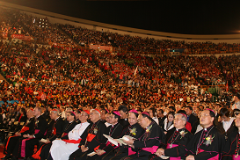 The National Taiwan Sport Stadium in Linkou was filled with more than 17,000 faithful from the seven dioceses of Taiwan. Everyone had been waiting for this great day of jubilation, grateful for the gift of faith and rejoicing for being together as one family for the past 150 years. Indeed, with the cardinals, bishops, priests, religious and faithful from all walks of life, we witnessed the universal dimension and beauty of the Church.

Cardinal Tomko’s homily

Cardinal Tomko focused his homily on Christ the King. But who is this King? “He is Jesus of Nazareth, an extraordinary man. He is not like other founders of religions. His birth from Virgin Mary, his life, his message, his works and miracles, his death and especially his resurrection are special and unique. No other man was able to rise from the dead. He is alive and continues to take care of his kingdom. In one word, he is not only a perfect man; he is the Son of God. That makes a difference!” said the Cardinal.

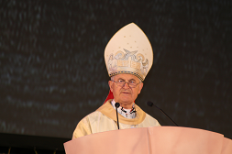 “Closing the celebrations on the Solemnity of Christ the King has special significance”, Cardinal Tomko stressed. “It is a new call to continue and rekindle the efforts of evangelization which means to build the kingdom of Jesus Christ. All members of the Church are called to this task in a personal way… This kingdom is of spiritual nature… By the means of evangelization we offer our society the fundamental values of the kingdom of Christ: the truth and the life”.

A wonderful surprise: an Archbishop “ad personam”

A wonderful surprise was announced after the homily. At the conclusion of the 150th anniversary of the evangelization in Taiwan and in appreciation of the historic role of Kaohsiung as the “mother church” the Holy Father Benedict XVI, had granted to the actual Bishop of this Diocese, Msgr. Peter Liu Cheng-Chung, the honorific title of Archbishop “ad personam”. This nomination serves as an encouragement to continue the work of the evangelization.

A challenge

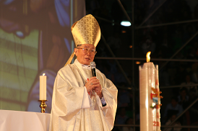The celebration did not end without a word from His Eminence Paul Cardinal Shan, SJ, Bishop Emeritus of Kaohsiung. Although the whole-year celebration of the 150th anniversary of evangelization had come to its end, yet it is also a new beginning. It is the beginning of a new period to evangelize with a new spirit. He hopes that each person, family, parish and diocese will have plans to spread the Good News to more people in order to help reform the society. At present the Church of Taiwan is already 150 years old yet she still relies on foreign missionaries. The Cardinal hopes that there will be more vocations in the future and one day, Taiwan will also be able to send missionaries to other countries: missionaries that are truly “made in Taiwan”.

A wish for priests

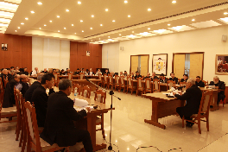 On November 22nd, Sunday, His Eminence Cardinal Tomko had a meeting with priests at the Taipei Curia. He elucidated to them the meaning of the Year of the Priesthood as well as the essence of the priesthood. This year, all priests should above all, reflect on their personal “interior renewal,” to be “more incisive witnesses,” being the “the love of the heart of Jesus” and “friends of Christ”. As Pope Paul VI rightly noted, “Modern man listens more willingly to witnesses than to teachers, and if he does listen to teachers, it is because they are witnesses’. Cardinal Tomko wishes that the priestly life of priests may be guided more and more by those ideals of the total giving of oneself to Christ and to the Church which inspired the thought and action of the saintly Curé of Ars.

Pastoral visits

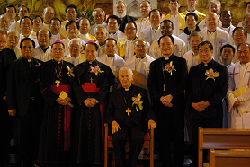 Cardinal Tomko, the Special Envoy of Pope Benedict XVI, continued his visit to Kaohsiung, the most badly hit by Typhoon Morakot, on November 23rd, Monday. On Tuesday, he visited Tainan in the morning and Taichung in the afternoon. In Taichung, he had Mass and meeting with the clergy from Chiayi, Taichung and Hsinchu. Cardinal Tomko returned to the Vatican on November 25th bringing good news of our celebrations to our Holy Father Pope Benedict XVI.

A historical event and a new beginning

Indeed, everyone was very much moved and inspired by the celebrations of the 150th anniversary of evangelization in Taiwan. Everyone feels so blessed to be a witness and part of what the Church is today. The presence of the Special Envoy, foreign missionaries, brothers and sisters from all over the world, made each one feel the universality of the Church. The Solemn Mass made us feel that the Eucharist is really the source of unity and strength for the people of God. Yet, this is not the time to stop and be contented. The work must go on and as we face the challenges of a new period of evangelization, we ask Our Blessed Mother, Saint Joseph and Jesus Christ to accompany us in our journey.

